Lab Exercise 13- Automation Testing using GitHub Actions (For Spring Boot API + Postman + Newman)

1. Objective
In this lab, learners will:
- Push a Spring Boot project to GitHub
- Add Postman collection tests
- Create a GitHub Actions workflow
- Run automated API tests using Newman in CI
- View test reports directly in GitHub Actions
- Make the build fail if any test fails

2. Prerequisites
Install:
- Git
- GitHub account
- Jenkins not required
- NodeJS (if you want to test locally)
- Postman to create and export test collections
You should already have:
- Spring Boot API
- Postman collection (.json)

3. Folder Structure for the Lab
Your GitHub repository structure should include:
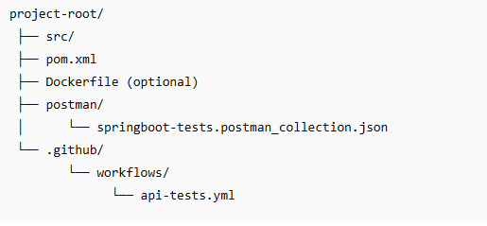

4. Step 1: Upload Spring Boot Project to GitHub
In your system:
git config --global user.name "Your Name"
git config --global user.email "your_email@example.com"

git init
git add .
git commit -m "Initial Spring Boot API commit"
git branch -M main
git remote add origin https://github.com/<username>/<repo>.git
git push -u origin main

6. Step 3: Add GitHub Actions Workflow
Inside it create:
api-tests.yml

7. Complete GitHub Actions Workflow
This workflow:
- Checks out your code
- Installs Java (Maven)
- Builds Spring Boot project
- Starts Spring Boot API server
- Installs Newman
- Runs Postman collection tests

Copy this EXACT file:
name: API Automation Testing

on:
push:
branches: [ "main" ]
pull_request:
branches: [ "main" ]

jobs:
run-api-tests:
runs-on: ubuntu-latest

steps:
- name: Checkout code
uses: actions/checkout@v4

- name: Set up JDK 17
uses: actions/setup-java@v4
with:
java-version: "17"
distribution: "temurin"

- name: Build Spring Boot App
run: mvn -B package --file pom.xml

- name: Run Spring Boot App in background
run: |
nohup java -jar target/*.jar &
sleep 20

- name: Install Newman
run: |
npm install -g newman
npm install -g newman-reporter-htmlextra

- name: Run Postman Tests with Newman
run: |
newman run postman/Simple-Spring-Boot-API-Testing.postman_collection.json \
-r htmlextra --reporter-htmlextra-export newman-report.html

- name: Upload Test Report
uses: actions/upload-artifact@v4
with:
name: API-Test-Report
path: newman-report.html

8. Step 4: Commit and Push the Workflow
git add .github/workflows/api-tests.yml
git commit -m "Added automated API testing workflow"
git push

9. Step 5: Run the CI Pipeline
Go to GitHub:
GitHub → Actions → API Automation Testing → Artifacts You will see the workflow running automatically after each push.

10. Understanding the Workflow Stages
1. Checkout code
Clones your repository.
2. Set up Java
Installs JDK (needed for Spring Boot build).
3. Build application
Runs Maven to build a .jar file.
4. Run application
Starts the API on port 8080 inside GitHub Actions VM.
5. Install Newman
Installs CLI runner for Postman tests.
6. Execute tests
Runs your Postman collection through Newman.
7. Upload report
Stores report as downloadable artifact.

